CloudCME® Mobile App

The CloudCME® mobile app provides seamless access to educational content and CE tasks, enabling users to manage participation, submit evaluations, and claim credit from their devices. With a single login, it streamlines CE management, offering an efficient, user-friendly hub for all CE activities.
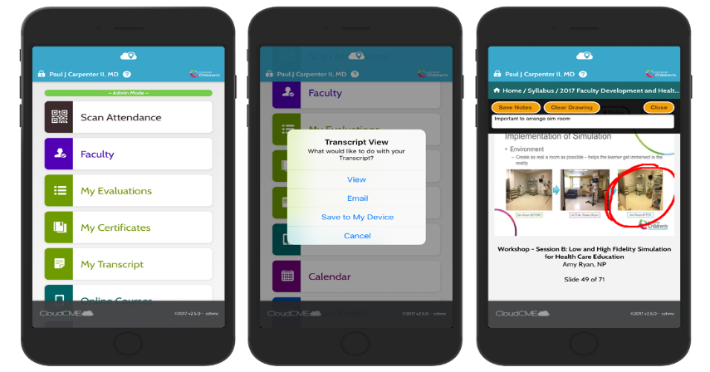

Download Link
Download the app for free from the app store and login using their organizational code (which is the prefix for your CloudCME® portal url, xxxxx.cloud-cme.com) and then enter your CloudCME® login name and password. Both institutional Single Sign-On and non-Single Sign-On CloudCME® account types are supported.

Apple iOS - https://itunes.apple.com/us/app/cloudcme/id624053130?mt=8
Google Android - https://play.google.com/store/apps/details?id=com.healthstream.cloudcme

Via CloudCME® Mobile App

Step 1: Download the app if you have not already
Step 2: Open the app, use organization code {Enter your organization’s code}
Step 3: Click the Login or Create Account button.
Step 4: Login using your email address and password.

Mobile App Features:
My Profile – allows you to create and manage your account in CloudCME®.

My Evaluations -allows you to complete activity evaluations.

My Certificates – allows you to view, print or email certificates.

My Transcript – allows you to view, print or email your transcript.

Online Courses – allows you to access online activities and complete them.

Syllabus – allows you to view activity syllabi, view uploaded presentations and take notes on the displayed presentations.

Calendar – allows you to view upcoming CE activities.

Scan Attendance – allows you to record your attendance, when applicable.

Audience Response - allows you to participate in audience response polls, when applicable.

Faculty – if you serve as faculty to CE activities, this allows you to access and complete your faculty assigned tasks including disclosure of financial relationships

